A Great Yoga Pose for Beginners As Well as for Back Pain Relief
Cat-Cow is a very common sequence in yoga classes; it is almost as ubiquituos as Downward Dog, or Adho Mukha Swanasana. There is good reason for this: Despite it's somewhat simplistic name, Cat-Cow (we prefer its Sanskrit name, Marjariasana) it is a great yoga pose for beginners, an excellent spine revitalizing sequence, and a great yoga exercise for back pain. It also gently tones the female reproductive system and is an excellent prenatal yoga sequence up to the second trimester. Some yoga masters maintain that it can also help bring relief from cramps if practiced during your monthly cycle.
The key to Cat-Cow is multiple repetitions. Move through the movement slowly and with awareness for 2-3 minutes. The repeated repetitions create a gentle massaging action, which increases the circulation to the discs between the vertebrae. This augments the suppleness and health of the vertebral discs and enhances the all-important cushioning action they create for the spine.
Cat-Cow also improves the vital information flow through the spinal cord, creating an overall energizing effect. To feel this, make sure to rest for 20-30 seconds after having done the sequence for 2-3 minutes, allowing your mind to be absorbed in the shift of sensations in the body. This is an important energetic integration taking place, which is enhanced by your awareness. Taking a moment to tune in to your body after each of the following two sequences also enables you to become aware of the effect these simple, rhythmic sequences have in your entire body.
This yoga pose sequence has two stages to it: Cat-Cow and Cat Wheel. The benefits of this yoga asana is greatly enhanced if the stomach is contracted towards the spine during exhalation.
Cat-Cow (Marjariasana)
1. Come into Table Pose with your knees under your hips and your hands under your shoulders. The spine is in neutral, parallel to the floor.
2. As you inhale, curve your spine, bringing your tailbone upwards and looking up towards the ceiling. As you exhale, hunch your spine, bringing your spine towards the ceiling.
3. Slowly and deliberately continue the movement back and forth in tune with your breath. As your spine gets warmer, see if you can dwell a little longer at your edge. Ease your spine a little deeper into the stretch at each extreme—as always without forcing and pushing. Continue for 1-2 minutes, then if you feel like it, move into the variations.
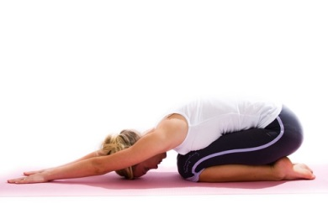
Variation: Cat Wheel
1. Come back into Table Pose on all fours. As you exhale, begin to move your buttocks towards your feet. Come all the way back into Child’s pose, resting your buttocks on your feet.
2. As you inhale, shift your weight towards your forearms, and at the same time curve your spine, slowly moving forward. Shift your weight forward as far as you can coming towards a Cobra pose.
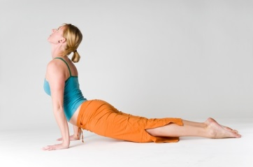3. Come back up into Table Pose, and repeat. With this pose, you basically create a circular motion with your spine. The upper part of the circle is created as you come into Cat hunch and move towards your feet. The lower part of the circle is created as you shift your weight onto your forearms and curve the spine into a Cow pose, and then back up into Table Pose. As you inhale, move back into table.
4. Continue back and forth, letting the movement unfold from the breath.
Explorations
- Cat-cow not only massages the spine, it is also an excellent core strengthener. Can you exaggerate the abdominal action by pulling the navel towards the spine as you exhale and hunch into the Cat pose?
- Hunch your spine slightly. As you move towards your feet, find the place halfway down towards your feet where your lower back feels the tightest. Very slowly make small circles into that area of tightness, massaging and opening up your lower back.
- Can you feel the different ways your core muscles are challenged as you move through the variations of Cat-Cow?
- Bend your arms and come down on your forearms in modified Table Pose. Try doing Cat-Cow here for greater range of motion.
- Cat-Cow is a great invitation to explore non-linear movements of the spine. In Table pose, with your hands on the floor, tune into your body and see if you can discover ways your spine wants to move. A figure 8, an undulating movement, a twisting, rotating, every-which-way, non-descript kind of movement? Listen to the impulse of movement in your body and see where it takes you.

